Ex. No. 2 | WORKING WITH HTML5 FORM AND MEDIA ELEMENTS
Date of Exercise | 21/07/26
GitHub Host Link | https://pranavkrishna136.github.io/web-tech-lab/

Aim

To design an E-Commerce Electronics Store webpage using HTML5 by implementing form elements and media elements such as input fields, select, fieldset, audio, video, embed, iframe, and progress bar.

Description
This experiment implements a E commerce electronic store webpage using HTML5 form and media elements. It uses tags such as <form>, <input>, <label>, <fieldset>, <select>, <textarea>, and <progress> to collect and display user information. Media tags such as <audio>, <video>, <embed>, <iframe>, and <img> are used to display gardening-related media and content. The webpage is organized using <div>, headings, paragraphs, hyperlinks, and HTML comments.

Procedure
- Create a new HTML5 file named index.html.
- Add the basic HTML structure using <html>, <head>, <title>, and <body>.
- Create the E Commerce Electronic Store layout using <div>, headings, paragraphs, images, and hyperlinks.
- Add form elements using <form>, <fieldset>, <label>, <input>, <select>, and <textarea>.
- Use <progress> to display gardening skill levels.
- Add media using <audio>, <video>, <embed>, and <iframe>.
- Save the file and open it in a browser.
- Verify that all form and media elements are displayed and working correctly.

Program
<!DOCTYPE html>
<html lang="en">
<head>
<meta charset="UTF-8">
<meta name="viewport" content="width=device-width, initial-scale=1.0">
<title>MVerse Electronics Store</title>
<style>
body {
font-family: Arial, sans-serif;
margin: 0;
padding: 20px;
background: linear-gradient(135deg, #eaf4ff, #f7fbff);
color: #1f2a44;
}

.container {
max-width: 1100px;
margin: 0 auto;
background: #ffffff;
padding: 25px;
border-radius: 12px;
box-shadow: 0 4px 16px rgba(0, 0, 0, 0.12);
}

h1, h2, h3 {
color: #0b5fa5;
}

h1 {
text-align: center;
background: #0b5fa5;
color: white;
padding: 15px;
border-radius: 8px;
}

.hero {
margin-bottom: 20px;
padding: 20px;
background: #f3f8ff;
border-left: 6px solid #0b5fa5;
}

.card {
margin: 20px 0;
padding: 15px;
border: 1px solid #dce9f7;
border-radius: 8px;
background: #fcfdff;
}

img {
width: 180px;
height: 150px;
border-radius: 8px;
margin-right: 15px;
}

a {
color: #0b5fa5;
text-decoration: none;
font-weight: bold;
}

table {
width: 100%;
border-collapse: collapse;
margin-top: 10px;
}

th, td {
border: 1px solid #c7dceb;
padding: 10px;
text-align: left;
}

th {
background: #e7f3ff;
}

.media-grid {
display: grid;
grid-template-columns: repeat(auto-fit, minmax(280px, 1fr));
gap: 15px;
}

.two-column {
column-count: 2;
column-gap: 20px;
}

form {
margin-top: 10px;
}

fieldset {
padding: 15px;
border: 1px solid #c7dceb;
border-radius: 8px;
}

input, select, textarea, button {
margin-top: 6px;
padding: 8px;
border: 1px solid #c7dceb;
border-radius: 6px;
width: 100%;
box-sizing: border-box;
}

progress {
width: 100%;
}

@media (max-width: 700px) {
.two-column {
column-count: 1;
}
}
</style>
</head>
<body>
<!-- Student Assignment: HTML5 Web Page with Forms and Media -->
<div class="container">
<h1>MVerse Electronics Store</h1>

<div class="hero">
<h2>Welcome to Our Store</h2>
<p>We offer modern electronics, fast service, and secure payment options for every customer.</p>
<p>Explore our laptops, mobiles, audio devices, and smart accessories.</p>
<a href="#order">Place Your Order</a>
</div>

<div class="card">
<h2>Featured Product</h2>
<img src="images/laptop.jpg" alt="Laptop image">
<p><strong>Gaming Laptop</strong></p>
<p>Powerful performance, full HD display, and long battery life.</p>
<a href="https://www.amazon.in" target="_blank">Buy Now</a>
</div>

<div class="card">
<h2>Price List</h2>
<table>
<tr>
<th>Product</th>
<th>Price</th>
</tr>
<tr>
<td>Laptop</td>
<td>₹55,000</td>
</tr>
<tr>
<td>Mobile</td>
<td>₹20,000</td>
</tr>
<tr>
<td>Headphones</td>
<td>₹2,500</td>
</tr>
</table>
</div>

<div class="card">
<h2>Electronics Showcase</h2>
<p>Enjoy a short audio clip and a demo video related to our electronic products.</p>

<h3>Audio</h3>
<audio controls>
<source src="thattathin_marayath.mp3" type="audio/mpeg">
Your browser does not support audio playback.
</audio>

<h3>Video</h3>
<video width="100%" controls poster="images/laptop.jpg">
<source src="vidssave.com iPhone Air Unboxing Space Black 1080P.mp4" type="video/mp4">
Your browser does not support video playback.
</video>
</div>

<div class="card" id="order">
<h2>Order Form</h2>
<form action="#" method="get">
<fieldset>
<legend>Customer Details</legend>
<label for="name">Name</label>
<input type="text" id="name" name="name" placeholder="Enter your name">

<label for="email">Email</label>
<input type="email" id="email" name="email" placeholder="Enter your email">

<label for="phone">Phone</label>
<input type="tel" id="phone" name="phone" placeholder="Enter phone number">

<label for="product">Choose Product</label>
<select id="product" name="product">
<option value="laptop">Laptop</option>
<option value="mobile">Mobile</option>
<option value="headphones">Headphones</option>
</select>

<label for="address">Address</label>
<textarea id="address" name="address" rows="4" placeholder="Enter your address"></textarea>

<label for="progress">Order Progress</label>
<progress id="progress" value="70" max="100"></progress>

<div style="margin-top: 12px;">
<input type="submit" value="Submit">
<input type="reset" value="Reset">
</div>
</fieldset>
</form>
</div>

<div class="card">
<h2>Location</h2>
<p>Visit our electronics store at the city center.</p>
<iframe src="https://www.google.com/maps?q=Chennai&output=embed" width="100%" height="300" style="border:0;" allowfullscreen="" loading="lazy" referrerpolicy="no-referrer-when-downgrade" title="Store location map"></iframe>
</div>

<div class="card">
<h2>Why Choose Us?</h2>
<div class="two-column">
<p>✔ Genuine products and warranty support.</p>
<p>✔ Affordable prices for students and professionals.</p>
<p>✔ Fast delivery and friendly customer service.</p>
<p>✔ Secure payment and easy returns.</p>
</div>
</div>
</div>
</body>
</html>

OUTPUT

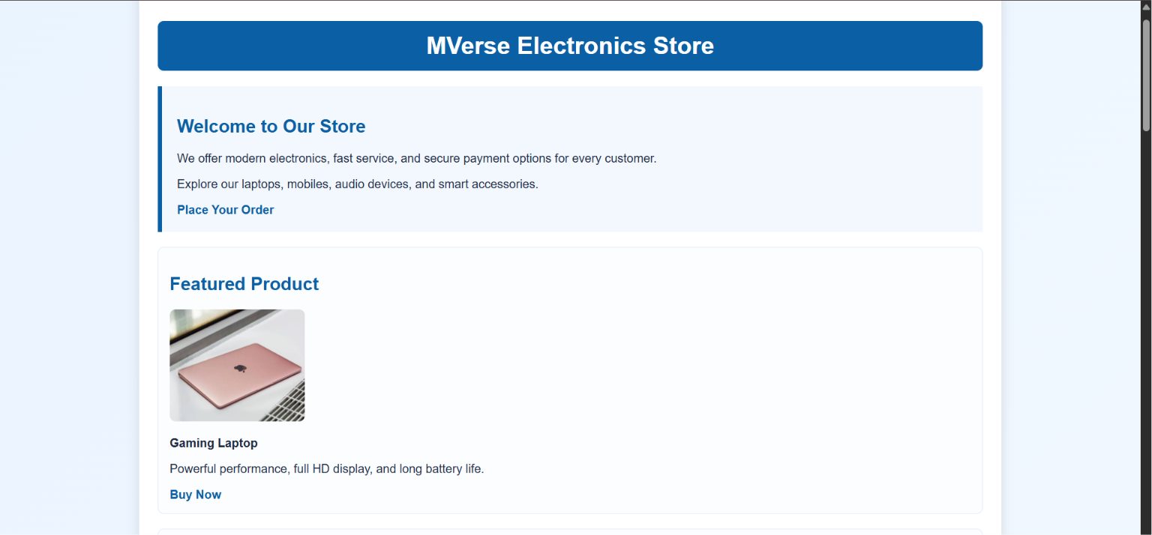

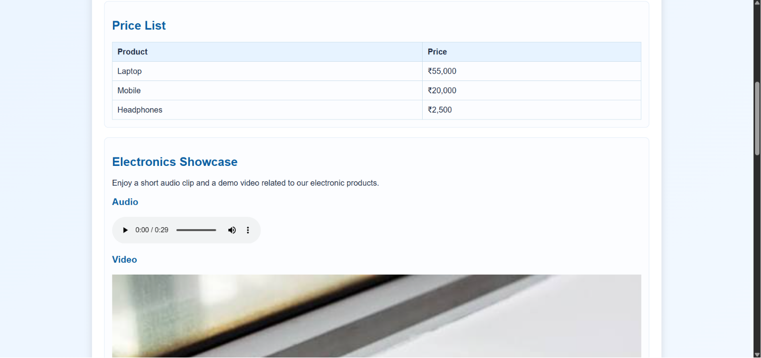
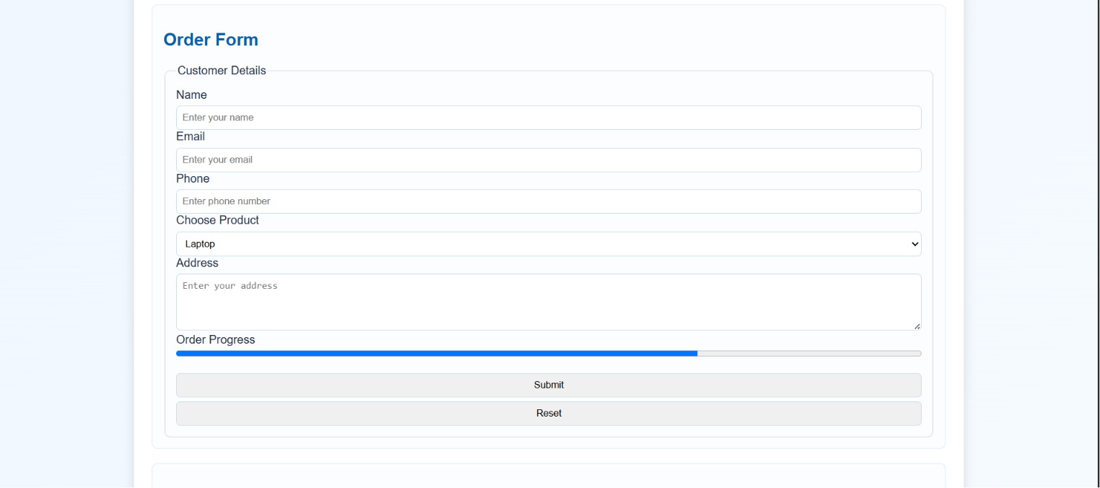

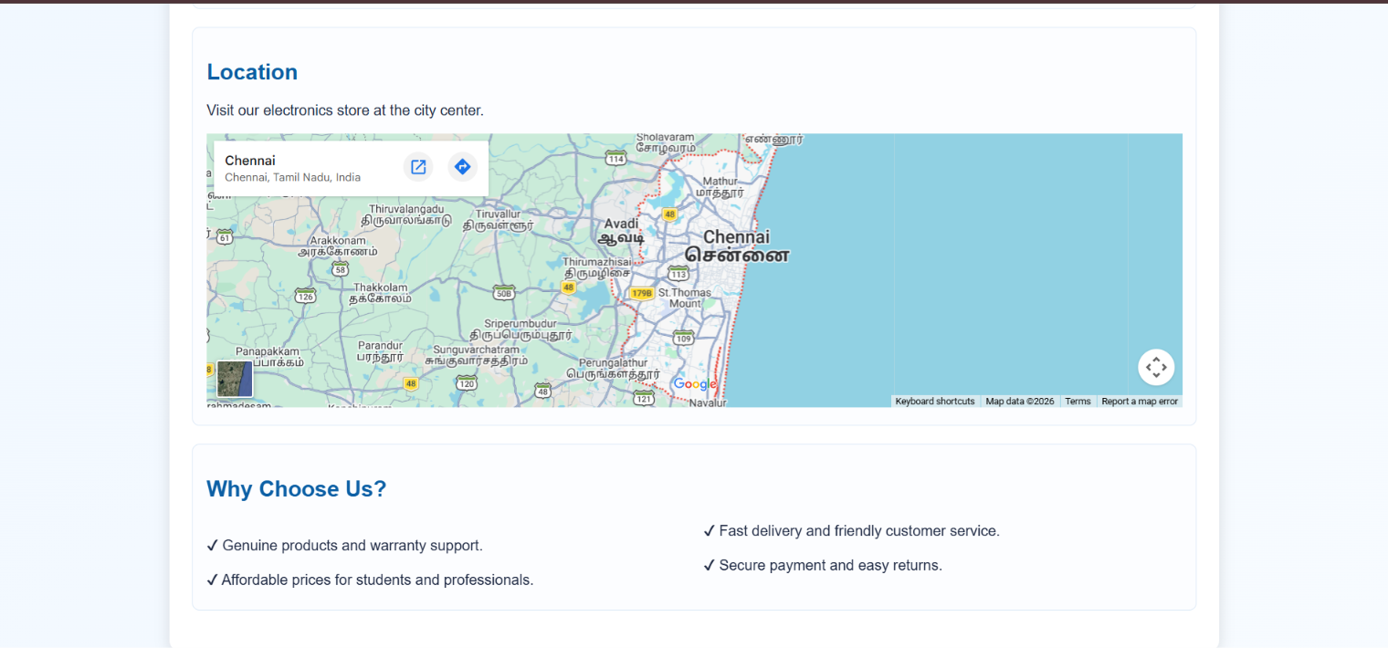

Result
The E-Commerce Electronics Store webpage was successfully designed and executed using HTML5 and CSS3. The webpage displayed all the required form and media elements correctly, and the output matched the expected design.

